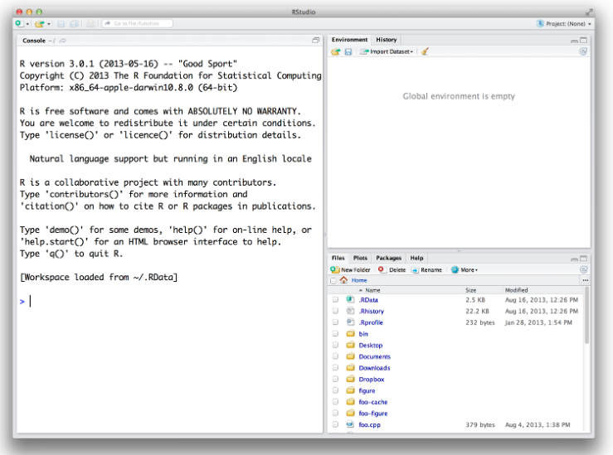**Nature management 2020**

**Carbon and nutrient week**

**Exercise 2**

**Preparations:**

1. Install R
   * Go to <https://cran.rstudio.com/>
   * Click download R for Mac/Windows/Linux depending on your operation system
   * Run installer
2. After installing R, install Rstudio
   * Go to <https://rstudio.com/products/rstudio/download/>
   * Find and download the Mac/Windows/Linux installer depending on your operation system
   * Run installer
3. Open Rstudio and you should see something like this – great success!
4. To play with the model:
   * Download simple_lake_p_model.zip from Absalon or go to <https://github.com/KennethTM/simple_lake_p_model>, press the green ”Code” botton and download as .zip.
   * Unzip folder on your computer
   * Click ”simple_lake_p_model.Rproj” to open in Rstudio
   * Go to ”File” followed by ”Open File” in order to open the .R files in the folder
   * The main file is ”lake_p_model.R” try to run it by executing the code (Crtl+Enter)
   * You are ready to experiment with the lake P model!

**Lake P modeling:**

1. Run the script: 1) What does the input data consist of? 2) What does the constants describe? 3) What is the initial model values for the zooplankton, phytoplankton, water and sediment P pools?
2. Run the model and plot it (line 42): Is the lake in equilibrium with the initial values entered into the model?
3. Open the data.R file which contains the model input data. Change some values, save the file and run the lake_p_model.R file from the start. How does the changes affect the model?
4. How low does the inlet concentration have to be in order to half the P in the phytoplankton pool?
5. How long time will it take before the lake reaches a new equilibrium? Try to change the time settings (dt and tmax in lake_p_model.R file) to make the model run longer.
6. What happens with the lake if the stream running through the lake is partially diverted?
7. What happens if all of the sediment is removed to remove the internal load? Will this very costly project have an effect on the transparency of the water?
8. What happens if oxygen is added to the bottom water of the lake to ensure oxygenated conditions?
9. What happens with the different P pools if the lake is bio-manipulated through removal of planktivorous fish?
10. Will a single treatment with AlCl be able to improve the trophic state of the lake. Remember that AlCl dissociates into Al3+ that binds PO43- forming insoluble AlPO4 that sinks out to the sediment
11. Local politicians have a strong wish to transform the lake into a good swimming lake, with high transparency. What needs to be done and how long time will it take before it works.